How to create table in sql database

1. Go to database
2. Go to query editor

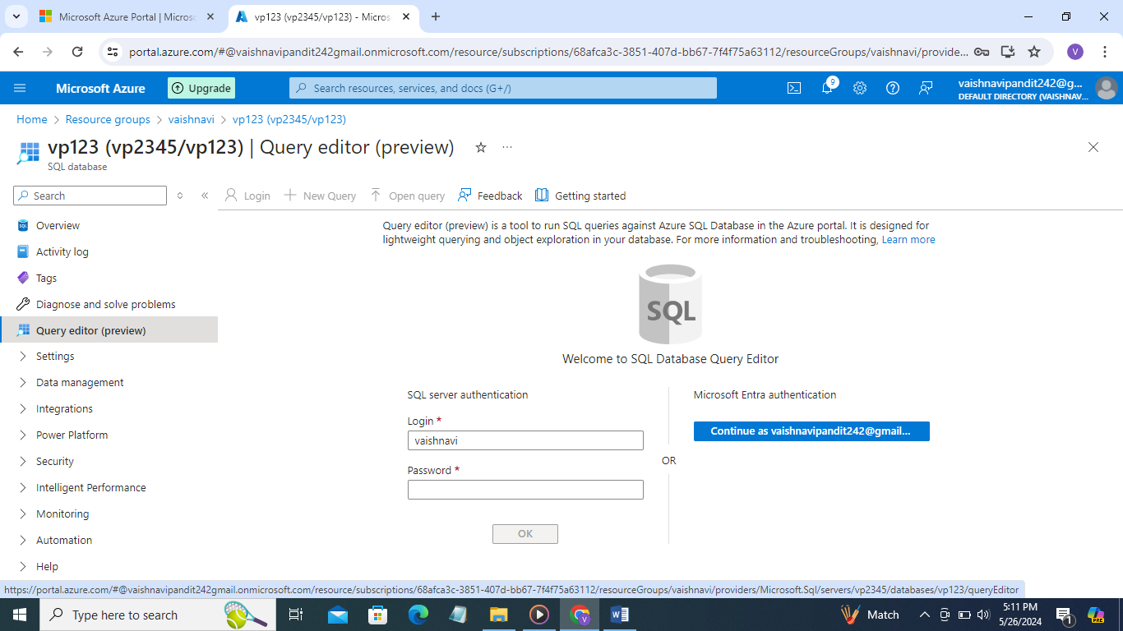

1. Enter sql server login id and password
2. Now go to query editor and write query to create table

